AProjectReport On

GeminiHistoricalArtifactDescription

Submittedby

228x1a4461 - srideepika
228x1a4455 Harivardhan
228x1a4433 Gowtham vasista
228x1a4431 Chaitanya Mani
228x1a4427 Shaik saidavali

LISTOFCONTENTS

CHAPTERNO NAMEOFTHECONTENTS PAGENO
LISTOF CONTENTS 2-3
CHAPTER1 INTRODUCTION 4-5
ProjectOverview 4
Purpose 5
CHAPTER2 IDEATIONPHASE 6-9
Problem Statement 6
EmpathyMap Canvas 7-8
Brainstorming 8-9
CHAPTER3 REQUIREMENT ANALYSIS 10-16
CustomerJourneyMap 10-11
SolutionRequirement 12-13
DataFlow Diagram 13-14
TechnologyStack 15-16
CHAPTER4 PROJECTDESIGN 17-21
ProblemSolutionFit 17-18
Proposed Solution 18-19
SolutionArchitecture 20-21
CHAPTER5 PROJECTPLANNING& SCHEDULING 22-23
ProjectPlanning 22-23
CHAPTER6 FUNCTIONALANDPERFORMANCE
TESTING 24-25
PerformanceTesting 24-25
CHAPTER7 RESULTS 26-29
Output Screenshots 26-29

CHAPTER8 | ADVANTAGES & DISADVANTAGES | 30
CHAPTER9 | CONCLUSION | 31
CHAPTER10 | FUTURESCOPE | 32
CHAPTER11 | APPENDIX | 33-37
SourceCode(ifany) Dataset Link
GitHub&ProjectDemo Link

CHAPTER-1 INTRODUCTION

PROJECTOVERVIEW
The Gemini Historical Artifact Description project is an AI-powered web application developedusingStreamlitandGoogle’sGenerativeAI(GeminiAPI).Themaingoalofthisproject is toautomatically generate detailed and meaningful descriptions of historical artifacts using text input and image input provided by the user.
The system allows users to upload an artifact image and enter additional prompts. Based on input, the Gemini model generates comprehensive historical information including origin, period,cultural significance, materials used, purpose, and interesting facts.
This project combinesArtificial Intelligence, Natural Language Processing, and Image Understandingtocreateaninteractivelearningplatform.Itisdesignedtoassiststudents, researchers,historians,museumcurators,andhistoryenthusiasts.Theapplicationdemonstratesthe real-time use of GenerativeAI in educational and cultural domains.
The Gemini Historical Artifact Description project is an AI-powered web application developed using Streamlit and Google’s GenerativeAI (GeminiAPI). The main objective of this systemistoautomaticallygeneratedetailedandmeaningfuldescriptionsofhistoricalartifactsusing text input and image input provided by the user.
The application allows users to upload an artifact image and provide additional prompts. Based on the input, the Gemini model generates structured historical information such as origin, time period, materials used, cultural significance, purpose, and interesting facts.
This project integrates Artificial Intelligence, Natural Language Processing (NLP), and Image Understanding to create an interactive learning platform. It demonstrates the real-time practical use of GenerativeAI in education, research, and cultural heritage domains.
The system is designed with a simple and user-friendly interface so that even beginners can easily generate high-quality historical content without requiring deep domain knowledge.

PURPOSE
The purpose of this project is to simplify historical research using Artificial Intelligence.Many students and researchers spend significant time searching multiple sources to understand artifacts. This project reduces that effort by generating structured and informative descriptions instantly.

Thesystemaimsto:

    - Reducemanualresearch time
    - Improveaccessibilitytohistoricalknowledge
    - ProvidestructuredAI-generatededucational content
    - Demonstratereal-timeGenerativeAIimplementation

The main purpose of this project is to simplify the process of understanding historical artifacts by using Generative AI technology. It aims to reduce the time and effort required for manual research.The project helps students, historians, museum curators, researchers, and history enthusiasts to quickly obtain well-structured and informative descriptions of artifacts.

Another important purpose is to demonstrate the real-time implementation of Google’s GeminiAI in a practical web application. This project also showcases howAI can support digital learning and cultural knowledge preservation.

Overall, the purpose of this system is to make historical knowledge more accessible, interactive, and efficient through AI-powered automation.

CHAPTER-2 IDEATIONPHASE

PROBLEMSTATEMENT
Understanding historical artifacts requires extensive research across books, journals, museumrecords,anddigitalresources.Manyusers,especiallystudentsandbeginners,donothave quick access to structured, accurate, and detailed descriptions of artifacts.
Manualresearchis:
- Time-consuming
- Notalwayswell-structured
- Requiresdomain expertise
- Sometimesdifficultforbeginners
- Dependenton availabilityofreliable sources
Additionally,existingonlineresourcesmayprovideincompleteorscatteredinformation, making it hard for users to understand the full historical context of an artifact in one place.
Therefore, there is a strong need for anAI-based system that can automatically generate detailed, meaningful,andwell-structuredartifactdescriptionsusingminimaluserinputsuchastextprompts or images. Such a system can improveaccessibility, reduce research time, and support learning in the field of history and cultural studies.
Inmanycases, availableonlineinformationisscatteredacrossmultiplesourcesandmay not always be reliable or easy to understand. Users often struggle to find complete details such as origin, cultural importance, materials used, and historical background in a single place.
Students and researchers may spend hours collecting information that could otherwise be summarized effectively. Beginners may also find it challenging to interpret complex historical terminology.
Therefore, there is a need for an AI-based intelligent system that can automatically generate clear, structured, and detailed artifact descriptions using minimal user input such as text or images.
Such a system would reduce research time, improve accessibility of knowledge, and provideconsistentandwell-organizedhistoricalinformationforeducationalandresearchpurposes.

EmpathyMapCanvas

The Empathy Map Canvas is a design thinking tool used to understand the needs, thoughts,feelings,andchallengesoftargetusers.Ithelpsinanalyzinguserbehaviorandidentifying problems from the user’s perspective. By studying what users think, feel, see, hear, say, and do, developers can design solutions that directly address real-world problems.

In the Gemini Historical Artifact Description project, the Empathy Map was used to understandthechallengesfacedbystudents,historians,museumcurators,researchers,andhistory enthusiasts. Many users struggle with finding structured and reliable information about historical artifacts. They often spend a significant amount of time searching through books, journals, and websites to gather complete details.

The empathy analysis revealed that users feel frustrated due to scattered information, complex historical terminology, and lack of centralized knowledge.They think about saving time and obtaining accurate information quickly. They see multiple incomplete resources online and hear suggestions from teachers or experts to use credible sources.

Byunderstandingtheseuserpainsandexpectations,theprojectwasdesignedtoprovide a solution that generates detailed and structured artifact descriptions using Generative AI. The empathy map helped in ensuring that the application is simple, user-friendly, time-saving, and informative.Thus, the Empathy Map Canvas played a crucial role in identifying user needs and shaping the overall design and functionality of the system.

Additionally,theEmpathyMaphelpsinimprovinguserexperiencebyfocusingonreal userexpectationsratherthanassumptions.Itensuresthatthesystemdesigniscenteredarounduser convenience and accessibility.
By clearly identifying user pains and gains, the project minimizes unnecessary complexity and maximizes usability. This user-centered approach increases the effectiveness and practical value of the Gemini HistoricalArtifact Description application.

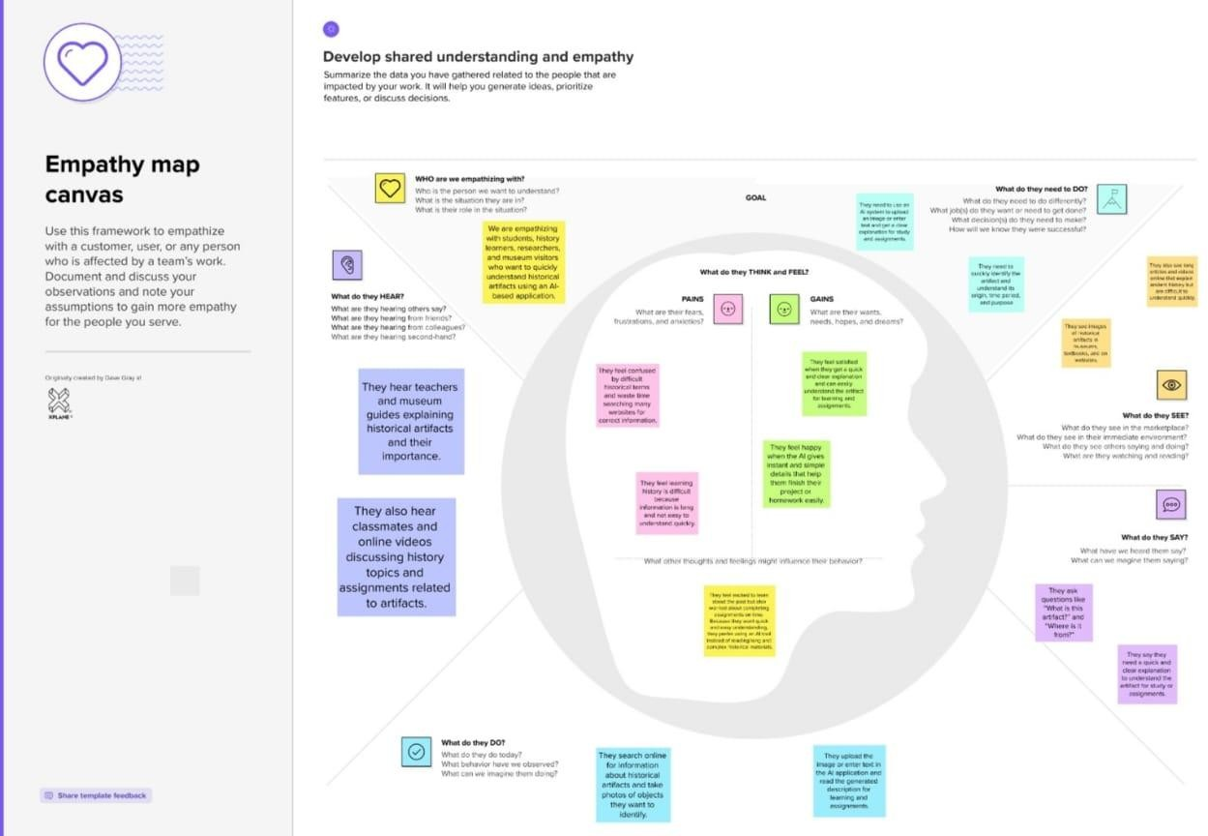

BRAINSTORMING
At the beginning of the project, we discussed real-life difficulties faced by students and learners while studying historical artifacts. Usually, when a person sees an ancient object such as a sculpture, coin, monument, or tool,they do not know its originor importance.To understand it, they must search many websites, books, or videos. The information available online is often scattered, complicated,andwrittenindifficulthistoricallanguage.Becauseofthis,beginnersfeelconfusedand spend a lot of time collecting data but still may not understand the artifact completely.
After identifying this problem, we thought about how technology can simplify the learning process.SinceArtificialIntelligenceandGenerativeAImodelsarecapableofunderstandingbothtext and images, we decided to create a system that automatically explains historical artifacts. The idea wastoallowuserstoeithertypeapromptoruploadanimageofanartifact.Duringideaprioritization, weselectedtheGeminiHistoricalArtifactDescriptionprojectbecauseitisuseful,practical,and

educational. The project combinesAI, Natural Language Processing, and image understanding in a single web application.
The expected outcome of this brainstorming is a real-time AI application that improves learning efficiency and saves time. Instead of searching multiple sources, users can directly obtain structured information within seconds. The system also promotes awareness of cultural heritage and supports modern digital learning methods. Therefore, this idea was finalized as it effectively solves a real-world educational problem using advanced AI technology.
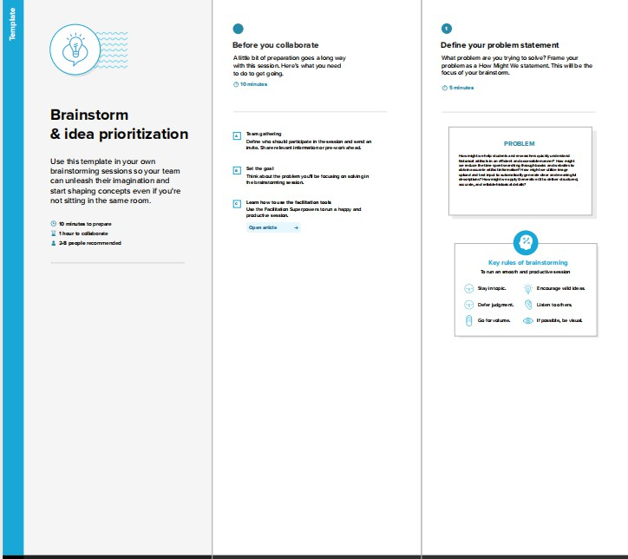

CHAPTER-3 REQUIREMENTANALYSIS

CUSTOMERJOURNEYMAP:
The customer journey map describes how a user interacts with the Gemini Historical Artifact Description System from the first visit to the final usage of the generated information. The process begins when the user opens the web browser and visits the Streamlit-based application.Onthehomepage,theuserfindsasimpleinterfacewithanimageuploadoptionanda text prompt field. The user uploads a picture of a historical artifact such as a coin, sculpture, or monument and optionally types a short query about it.After entering the input, the user clicks the “Generate Description” button to start the process.
In theengagement stage, the system sends the uploaded image to the Gemini Generative AI model. TheAI analyzes the object using image understanding and Natural Language Processingtechniques.Theuserwaitsafewsecondswhilethesystemprocessestherequest.After processing, a detailed description appears on the screen. The generated output includes historical background, origin, time period, materials used, cultural significance, and interesting facts. The user reads the information and understands the artifact easily without searching external sources.
Intheexitstage,theusercopiesthegeneratedtextortakesascreenshotforacademic use. The information can be used in assignments, presentations, or project reports. Some users may share the generated results with classmates or teachers. This stage shows the practical usefulness of the system in real educational environments because it saves time and provides structured knowledge quickly.
In the extend stage, satisfied users return to the website again to analyze another artifact.They may recommend the system to friends or useit during seminars and project work. The application encourages repeated usage because it is easy to operate and provides understandablecontent.Thesystemthereforesupportscontinuouslearningandawarenessabout cultural heritage.
Positive experiences in the journey include quick description generation, easy image upload,andbeginner-friendlylanguage.However,usersmayalsofaceminorissuessuchasslow internet loading time, incorrect identification for unclear images, or difficulty choosing the right

prompt.Futureimprovementscanincludemultilingualoutput,audionarration,artifactcategory detection, downloadable PDF reports, and improved accuracy through better prompt guidance.

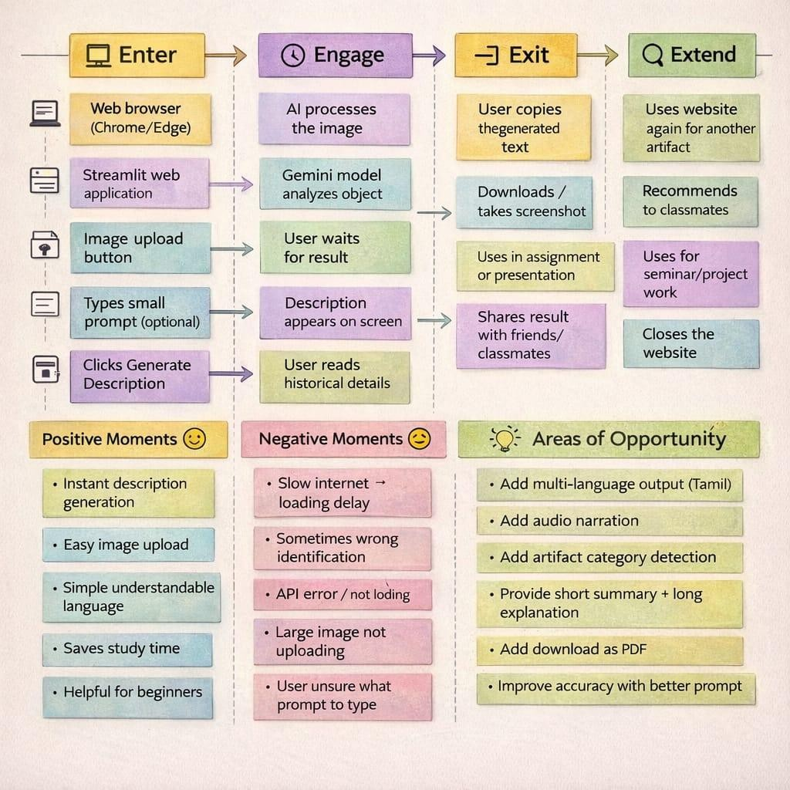

SOLUTIONREQUIREMENT:

FunctionalRequirements:
The proposed solution is anAI-powered web application that allows users to generate detailedhistoricaldescriptionsofartifactsusingbothimageandtextinput.Thesystemisaccessed through a web browser and provides a simple and interactive user interface developed using Streamlit.Afteropening theapplication, theusercan uploadan imageofahistorical object such as a coin, sculpture, monument, or tool. The system also allows the user to enter a short prompt or artifact name to guide theAI in understanding the object more accurately.Once the input is provided,theapplicationsendstheimageandtextprompttotheGeminiGenerativeAImodelfor processing. The AI analyzes the visual features of the artifact and produces a structured description that includes origin, historical period, materials used, cultural significance, purpose, and interesting facts. The generated content is displayed on the screen in readable language so that even beginners or students without historical knowledge can understand it easily.
Thesystemalso includeserrorhandlingfeatures. Iftheuser failstouploadanimageor if the API connection fails, the application displays an appropriate error message. During processing,thesysteminformstheuserthatthedescriptionisbeinggeneratedandmayalsoshow a short historical fact while waiting.This ensures continuous user engagement and improves the usability of the application.
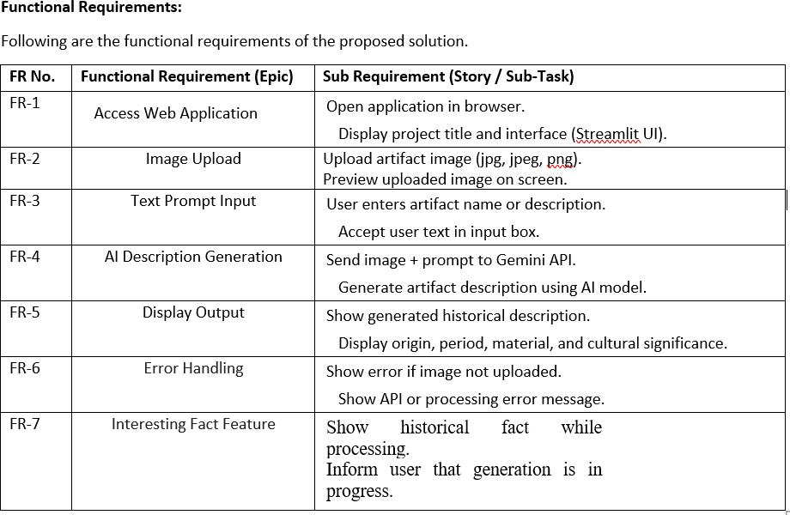

Non-FunctionalRequirements:
Apart from functional features, the system must satisfy several non-functional requirements to ensure quality and reliability.The application is designed with high usability so thatuserscanoperateitwithouttraining.Theinterfacecontainssimplebuttons,clearinstructions, and a straightforward workflow for uploading images and generating descriptions.
Security is an important aspect of the system.The GeminiAPI key is stored securely in an environment configuration file and is not exposed in the source code or public repositories. This prevents unauthorized access and protects the system from misuse. The application mustalsobereliableandconsistentlygenerateoutputswithoutcrashingorproducingemptyresponses.
TheperformanceofthesystemshouldallowtheAIdescriptiontobegeneratedwithina few seconds after the user clicks the generate button. The application must remain available whenever an internet connection is present and the server is running. Additionally, the system should be scalable enough to support multiple users accessing the application simultaneously without significant delay or slowdown.
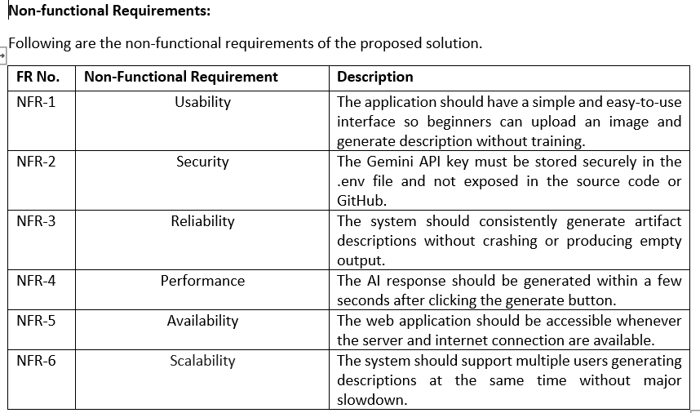

DATAFLOWDIAGRAM:
TheDataFlowDiagram(DFD)representshowdatamovesthroughtheGeminiHistorical Artifact Description System. It shows how user input is received, processed by the application, analyzedbytheAImodel,andfinallydisplayedasastructuredhistoricaldescription.Thediagram

helpstounderstandtheinternalworkingofthesysteminasimplegraphicalmannerbyillustrating processes, data stores, and data flow between components.
At the beginning of the process, the user (student, researcher, or visitor) interacts with thewebapplicationthroughabrowser.Theuseruploadsanartifactimageandoptionallyentersa shorttextpromptdescribingtheobject.ThisinformationisreceivedbytheUploadInputmodule. Theuploadedimageistemporarilystoredinthesystemandtheprompttextissavedasuserinput. Theseinputsactastheprimarydatarequiredforgeneratingtheartifactdescription.Afterreceiving the input, the system performs image processing. The application reads the uploaded image and convertsit into aformatsuitableforAIprocessing.Theprocessedimagedataalong with theuser prompt is then sent as a request to the Gemini GenerativeAI model. TheAI model analyzes the visual characteristics of the artifact such as shape, texture, and patterns and combines it with the prompt to understand the context of the object.Next, the GeminiAI Processing module generates adetaileddescription oftheartifact.Thegenerated output contains historical information such as origin, time period, materials used, cultural significance, purpose, and interesting facts. This generated description is stored temporarily in the system as output data.
Finally, the Display Output module presents the generated description on the user interface.Theusercanreadthehistoricaldetailsdirectlyonthescreenandusetheinformationfor learning, assignments, or research purposes. Thus, the DFD clearly shows the complete flow of data from user input toAI processing and final output display within the system.

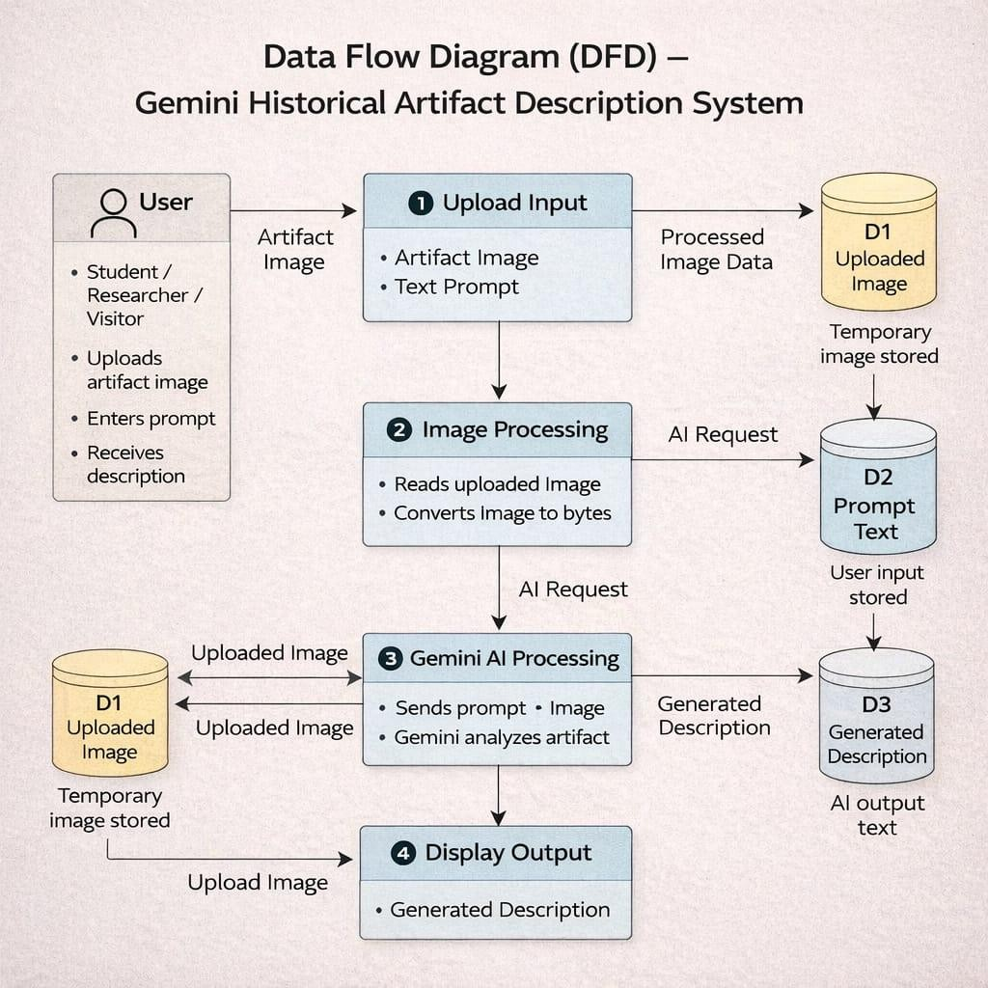

TECHNOLOGYSTACK:

The Gemini Historical Artifact Description System is developed as a web-based application using a combination of modern web technologies, artificial intelligence services, and image processing libraries. The application follows a simple client–server architecture in which theuserinteractswiththesystemthroughawebbrowser,whiletheprocessingandAIanalysisare handled by the backend application and external AI service.
Ontheuserside,thesystemisaccessedthroughastandardwebbrowsersuchasGoogle ChromeorMicrosoftEdge.TheinterfaceoftheapplicationisbuiltusingtheStreamlitframework, which provides an interactiveand easy-to-usegraphical interface.The user can uploadan artifact imageandenterashorttextpromptdescribingtheobject.TheStreamlitinterfaceincludesbuttons, inputboxes,andimagepreviewoptions, allowing userstoeasilyinteractwiththesystemwithout requiring technical knowledge.
ThebackendoftheapplicationisimplementedusingthePythonprogramminglanguage. Pythonisusedtohandleimageinput,manageuserrequests,andcommunicatewiththeAImodel. When a user uploads an image, the system processes the image using image-handling libraries suchasPIL(PythonImagingLibrary).Theimageisconvertedintoasuitableformatandcombined with the user prompt using prompt engineering techniques before sending it to theAI model.

For artificial intelligence processing, the system uses the Google Gemini GenerativeAI API as an external cloud service. The backend sends the processed image and text prompt to the GeminiAPI through an HTTP request. TheAI model analyzes the visual features of the artifact and generates structured historical information including origin, time period, materials used, culturalsignificance,andinterestingfacts.Thegeneratedresponseisreceivedbythebackendand formatted into readable text.
Finally,theprocessedoutputisdisplayedbacktotheuserthroughtheStreamlitinterface. The user can read the generated description directly on the screen and use the information for educational and research purposes. This technology stack ensures that the system is lightweight, easy to deploy, and capable of providing real-timeAI-based historical artifact descriptions.

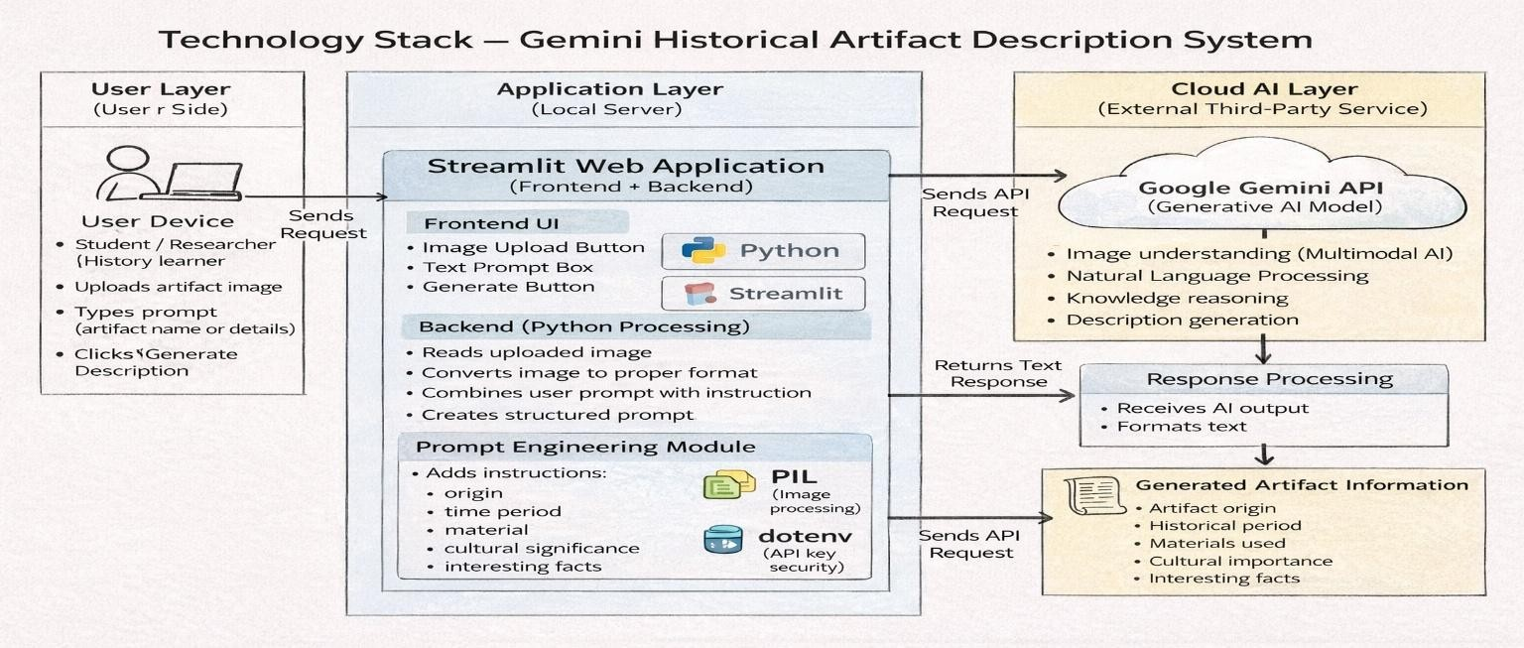

CHAPTER-4 PROJECTDESIGN

PROBLEMSOLUTIONFIT:
TheGeminiHistoricalArtifactDescriptionSystemisdesignedaftercarefullyanalyzingthe real problems faced by users while learning or identifying historical artifacts.The main target users of the system include students, teachers, researchers, museum visitors, and general history learners. Many students and beginners find it difficult to understand historical artifacts because the available information is scattered across textbooks, websites, and videos. Identifying an artifact requires searching through multiple sources, which consumes time and often creates confusion. Beginners especially do not know the correct keywords to search, and technical historical language makes understanding harder.As a result, users feel frustrated, waste time, and sometimes lose interest in learning history.
Currently,usersdependonGooglesearch,Wikipediaarticles,YouTubevideos,books,and teacher explanations. These methods require long reading and manual research. During exams, assignments, or seminar preparation, students struggle to quickly obtain clear information. When visiting museums or seeing an unknown artifact image online, users cannot easily identify the object or understand its historical importance. The root cause of the problem is the lack of a single platform that provides simple, instant, and understandable artifact explanations in one place.
To solvethisissue, the proposed system providesanAI-based web application wherethe user only uploads an artifact image and optionally enters a short prompt. The system uses the GeminiAI model to analyze the image and automatically generate a structured description. The outputincludestheorigin,timeperiod,materialsused,culturalsignificance,andinterestingfacts. This reduces manual searching and simplifies learning.After using the system, users gain clear understanding, save time, and become more confident in studying historical subjects.
The solution changes the user experience from confusion to clarity. Instead of reading multiplewebsites,usersreceivedirectinformationwithinseconds.Theapplicationcanbeaccessed through a web browser and used during assignments, classroom learning, seminars, or museum visits. Therefore, the system effectively fits the real user problem by providing a fast, easy-to-use, and educational AI-powered solution for understanding historical artifacts.

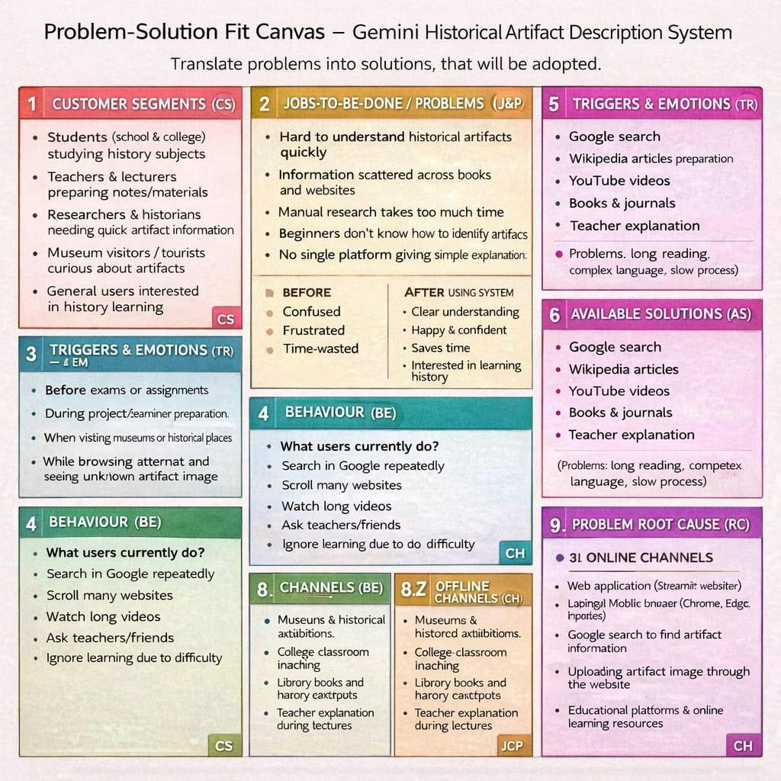

PROPOSEDSOLUTION:
The proposed system, Gemini Historical Artifact Description System, is a web-based application developed to simplify the understanding and identification of historical artifacts. Many students and beginners face difficulty in learning history because they must search through multiple books, websites, and videos to collect information about a single artifact. The information is often scattered, complex, and written in technical language, which makes learning time-consuming and confusing.Therefore,thesystemaimstoprovideasingleplatformwhereuserscaneasilyobtainclear and structured historical information within seconds.The solution works by allowing the user to uploadanimageofahistoricalartifact andoptionallyentera shorttextpromptdescribingwhatthey wanttoknow.TheapplicationprocessestheimageandsendsitalongwiththeprompttotheGemini GenerativeAImodel.TheAIanalyzestheartifactandautomaticallygeneratesadetailedexplanation

insimpleandunderstandablelanguage.Thegeneratedoutputincludestheartifact’sorigin,historical background, time period, material used, cultural significance, and interesting facts.The information is displayed instantly on the screen, reducing the need for manual research.
Thissystemisuniquebecause,unlikesearchengines,itdoesnotonlyprovidelinkstowebsites. Instead, it directly produces a complete explanation tailored to the user’s query. Even users without historical knowledge can understand the artifact easily. The platform supports students during assignments, teachers during lectures, and museum visitors who want quick information about displayed objects. By saving time and reducing effort, the system improves learning efficiency and encourages interest in history and cultural heritage.
Fromapracticalperspective, thesolutionisscalableandcanbeexpandedinthefuture.Itcan supportmultipleuserssimultaneouslythroughclouddeploymentandmayincludeadditionalfeatures such as multilingual output, downloadable reports, audio narration, and integration with museum databases.Afreemium usage model can also be adopted, where basic features are free for students while advanced features are provided to institutions and organizations. Thus, the proposed solution provides an efficient, user-friendly, and intelligent platform for real-time historical artifact understanding.
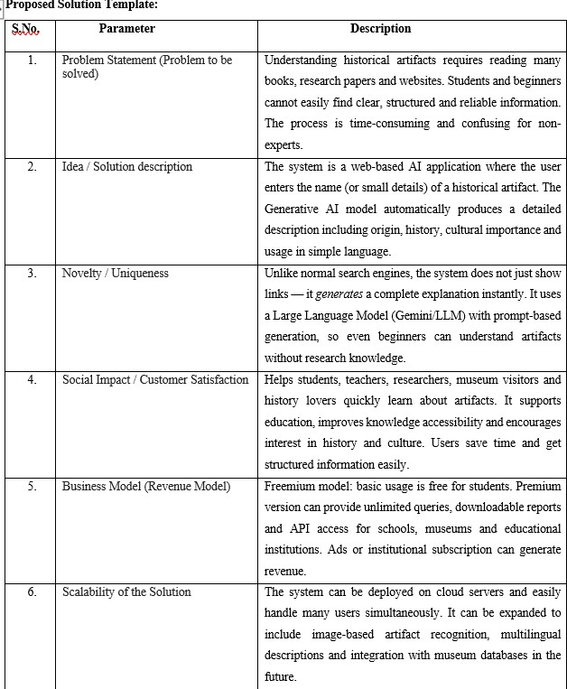

SOLUTIONARCHITECTURE:
The Gemini Historical Artifact Description System follows a layered architecture that separatestheuserinterface,applicationlogic,artificialintelligenceprocessing,anddatastorage. Thisstructureddesignmakesthesystem easy tounderstand,maintain, and expandinthefuture. The architecture mainly consists of four layers: Presentation Layer, Application Processing Layer, AI Processing Layer, and Data Storage Layer. Each layer performs a specific task and communicates with other layers to produce the final output.
ThePresentationLayerrepresentsthefront-endinterfacethroughwhichtheuserinteracts withthesystem.ThewebinterfaceisdevelopedusingaStreamlitwebapplication.Inthislayer, theuseruploadsanartifactimage,optionallyentersaprompt,andclicksthegeneratebutton.The interfacedisplaysthegenerateddescriptionclearlyonthescreen.Thislayerfocusesonusability and ensures that even beginners can operate the system easily without technical knowledge.
The Application Processing Layer acts as the core controller of the system and is implemented using Python. It receives user input from the web interface and performs input validation, image preprocessing, and prompt construction. The server converts the uploaded imageintoaformatsuitableforAIprocessingandpreparesastructuredrequest.Itthensecurely sends the request to the Gemini Generative AI API. After receiving the response, the server formats the output into readable text and sends it back to the user interface.
TheAIProcessingLayerusestheGeminiGenerativeAImodeltoanalyzetheartifact.The model processes both the image and the user prompt to identify the object and generate meaningful historical information. TheAI produces structured details such as origin, historical period,materialused,culturalsignificance,andinterestingfacts.Thislayerisresponsibleforthe intelligenceofthesystemandreplacesmanualresearchbyautomaticallygeneratinghuman-like explanations.
Finally,theDataStorageLayerstoresuploadedimages,generateddescriptions,anduser history. Temporary data may be saved for faster response and future reference. Storing results allows users to review previously generated artifact descriptions and helps improve system reliability.AlllayersworktogetherthroughsecureAPIcommunication,ensuringaccurateresults and fast performance.

Overall, thearchitectureprovides ascalableand efficientsolution.Themodulardesign allows future improvements such as multilingual output, downloadable reports, museum database integration, and support for multiple simultaneous users.This architecture ensures the system is reliable, user-friendly, and capable of delivering real-time historical artifact explanations.
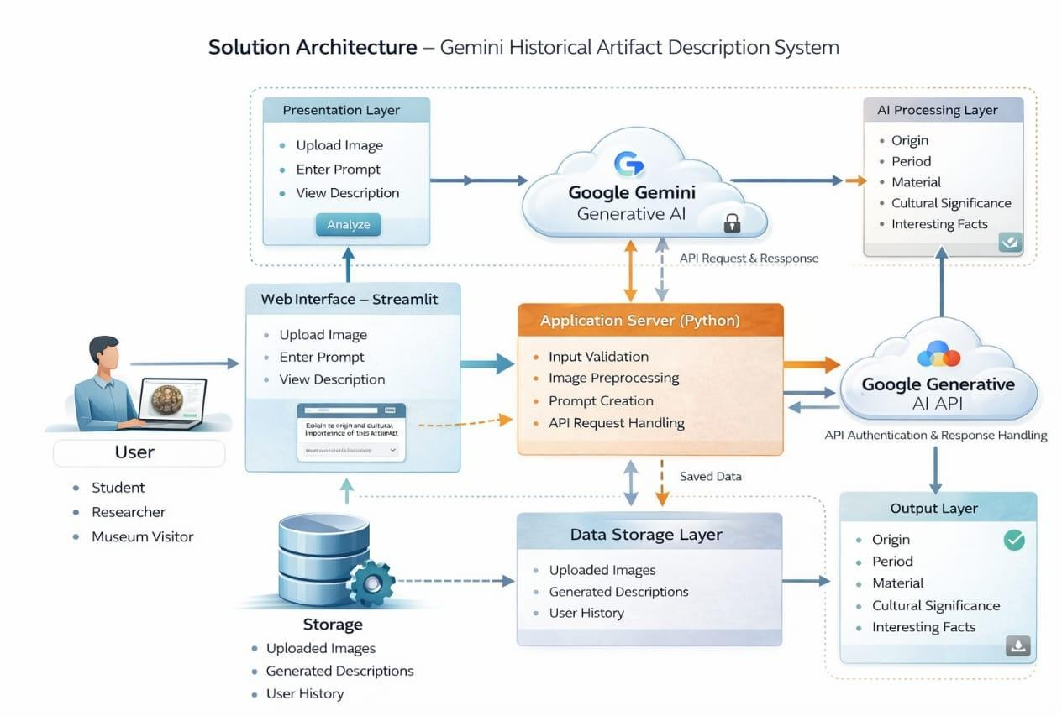

CHAPTER-5

PROJECTPLANNING&SCHEDULING

PROJECTPLANNING:
The development ofthe Gemini HistoricalArtifact Description System was carried out in a structured and organized manner using a simple software development lifecycle approach. The project work was divided into multiple phases such as planning, requirement analysis, design, implementation,testing,anddeployment.Properschedulinghelpedincompletingtheprojectwithin the academic timeline and ensured that each task was completed systematically.
Duringtheplanningphase,theprojectobjectivewasclearlydefined.Themainaimwasto develop anAI-based web application that can generate historical artifact descriptions using image input.Theproblemstatementwasidentifiedbyobservingthatstudentsandbeginnersfacedifficulty in understanding historical artifacts and spend a lot of time searching information from books and websites.Adevelopment plan was created, tools wereselected, and the working methodology was finalized.
In the requirement analysis phase, functional and non-functional requirements were collected.Functionalrequirementsincludeduploadingartifactimages,enteringprompts,generating descriptions usingAI, and displaying the output to the user. Non-functional requirements included usability, security of API keys, system reliability, and fast response time. Based on these requirements, the system design and workflow were prepared.
Duringthedesignphase,systemarchitecturediagrams,dataflowdiagrams,andcustomer journeymapswereprepared.TheinterfacelayoutwasdesignedusingStreamlitsothatuserscould easily upload images and view results. The communication between the application server and GeminiAIAPI was also planned. This stage helped in understanding how each component of the system interacts with each other.
In the implementation phase, the application was developed using Python and Streamlit. Theimageuploadfeaturewasimplementedfirst,followedbypromptinputandAPIintegration.

The Gemini Generative AI API was connected to process the image and generate historical information. The system was tested continuously while coding to ensure proper functionality.
In the testing phase, different test cases were executed to verify the correctness of the system.Inputvalidation,APIconnection,responsetime,andoutputaccuracywerechecked.Errors such as invalid input, image upload failure, and API response issues were handled properly. The performance of the system was measured to ensure that the response was generated within a few seconds.
Finally, in the deployment phase, the application was executed and demonstrated successfully. The generated descriptions were verified and documented. Necessary improvements were made based on testing results, and the final project documentation was prepared.

CHAPTER-6

FUNCTIONALANDPERFORMANCETESTING

PERFORMANCETESTING:
Testing is an important phase of the Gemini HistoricalArtifact Description System. It ensures that the application works correctly according to user requirements and produces accurateresults.Thetestingprocesswascarriedoutinreal-timeafterimplementingeachmodule of the system. The system was tested using different inputs such as valid images, invalid files, empty prompts, and network conditions to verify the behavior of the application.

FunctionalTesting
Functional testing verifies whether each feature of the system operates as expected. Every function such as imageupload, prompt input,AIprocessing, and output display was tested individually.The goal of this testing was to confirm that the system correctly accepts user input, processesthedatathroughtheGeminiAImodel,anddisplaysthegeneratedhistoricaldescription.
Whentheuseropensthewebapplication,theinterfaceshouldloadproperlyandshow theuploadoption.Afteruploadinganartifactimage,thepreviewshouldappearonthescreen.The user can optionally enter a prompt such as the name or details of the artifact. When the Generate Description button is clicked, the system sends the image and text to theAI model and displays the historical information including origin, period, material, and cultural significance.
Error handling was also verified. If the user clicks generate without uploading an image, the system displays a warning message. If an unsupported file format is uploaded, the system rejects it and asks for a valid image. If the internet connection fails or API response is unavailable, an appropriate error message is shown.

PerformanceTesting
Performancetestingevaluatesthespeed,responsiveness,andstabilityofthesystem underworkingconditions.Thesystemwastestedbyuploadingdifferentimagesizesandobserving theresponsetime.TheprimarygoalwastoensurethattheAIdescriptionisgeneratedwithinafew seconds and the application does not crash.
The system performance mainly depends on internet speed and AI API response time. In normal network conditions, the description is generated within approximately 3–8 seconds.Thesystemwastestedmultipletimescontinuouslytocheckreliability.Itwasalsoverified that multiple users can access the application without major delay.
Largeimagesweretestedtoobservesystembehavior.Theapplicationsuccessfully handled medium-sized images, while very large images slightly increased response time but still producedcorrectoutput.Memoryusageremainedstableandtheapplicationdidnotfreezeorstop during execution.

CHAPTER-7 RESULTS

OUTPUTSCREENSHOTS:
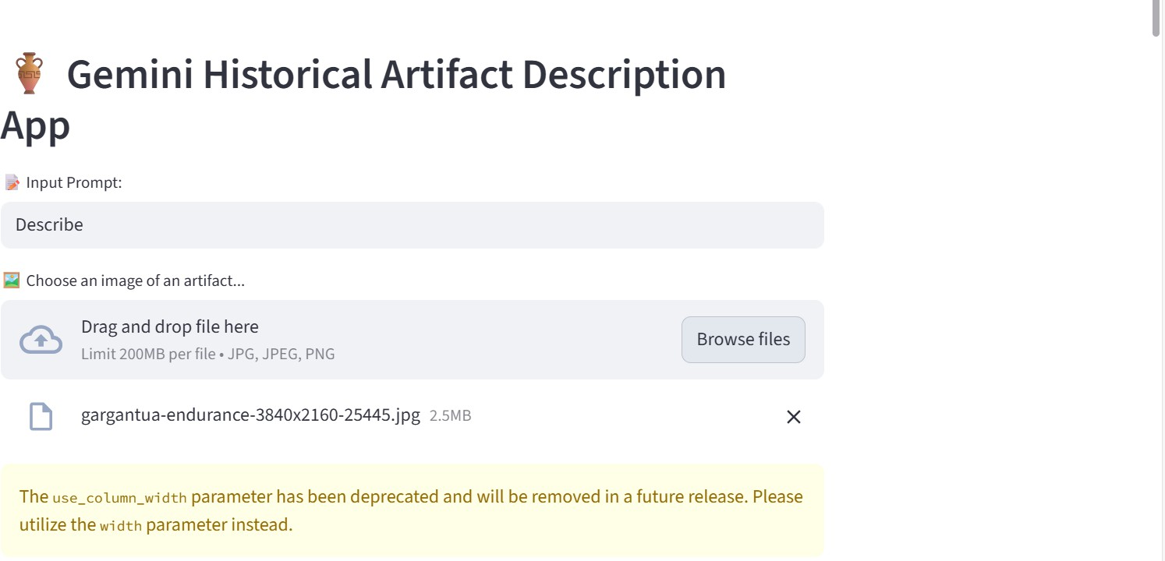

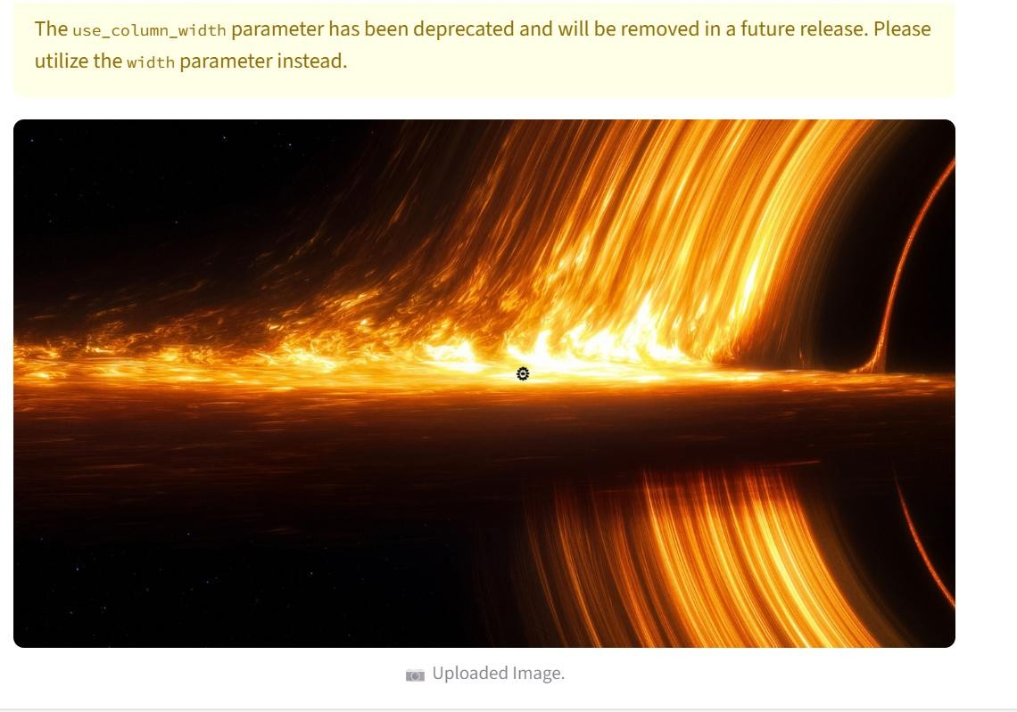

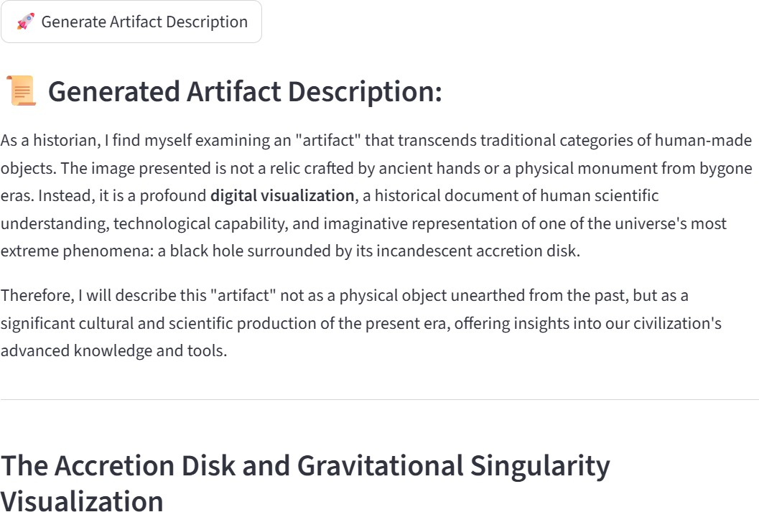

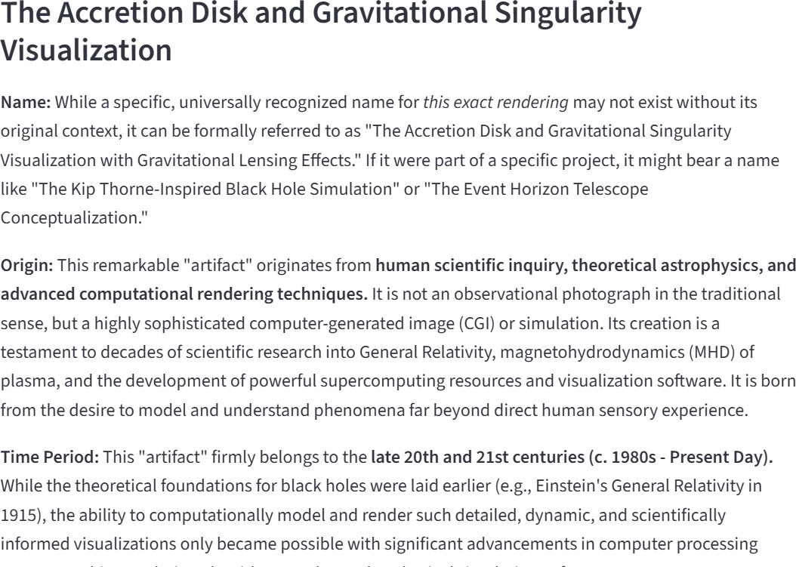

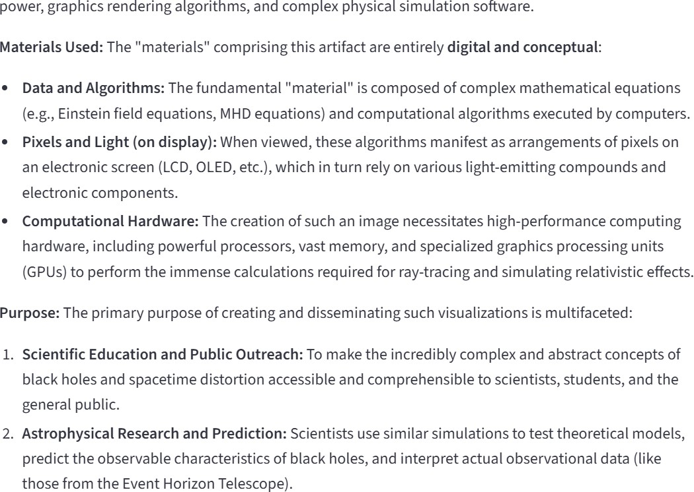

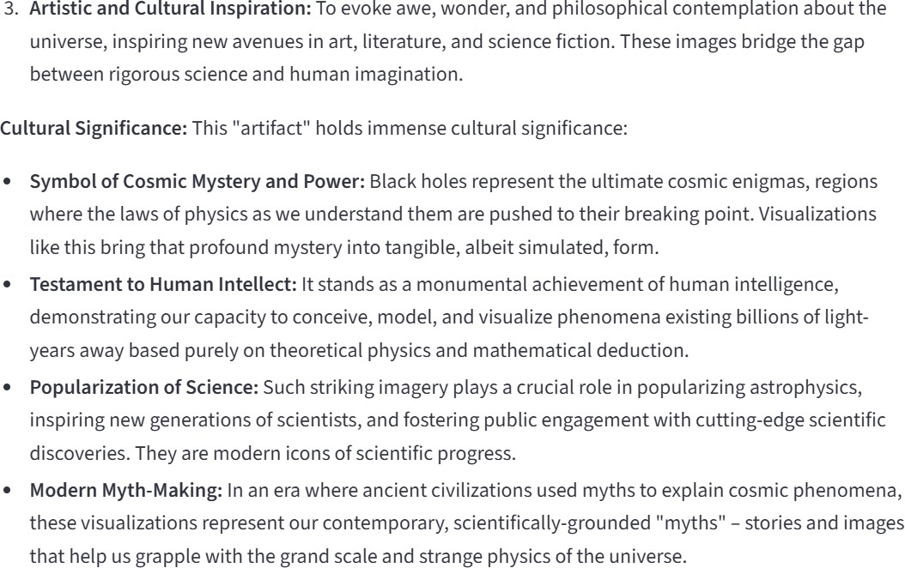

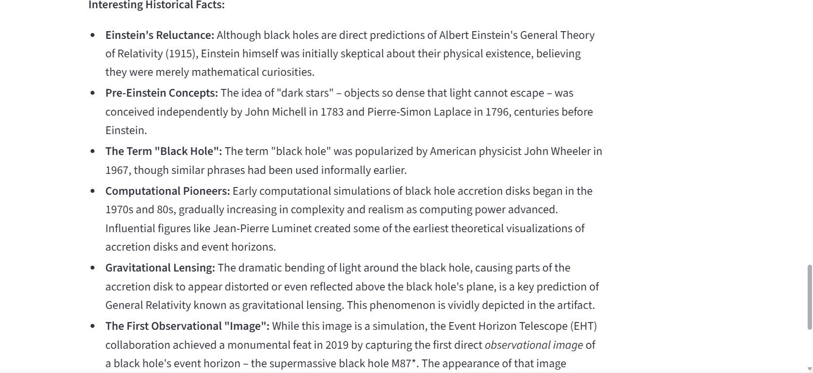

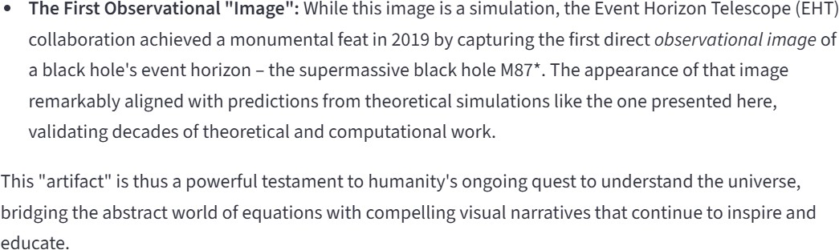

CHAPTER-8 ADVANTAGES&DISADVANTAGES

ADVANTAGES:
- ProvidesinstanthistoricalartifactdescriptionsusingAI.
- Savesresearchtimeforstudentsand researchers.
- Simpleanduser-friendlywebinterface.
- Generatesstructuredinformation(origin,period,material, significance).
- Helpfulforbeginnerswholackhistoricalknowledge.
- Accessiblefromanywherethroughaweb browser.
- Reducesdependencyon multiplebooksandwebsites.

DISADVANTAGES:
- RequiresstableinternetconnectionforAIprocessing.
- DependsonexternalAPI(Gemini),sodowntimemayaffect usage.

- Maysometimesgenerateslightlyinaccurate information.
- Performancemayreducewithverylargeimagefiles.
- Limitedfeaturesinbasic version(iffreemiummodelused).

CHAPTER-9 CONCLUSION

CONCLUSION:

The Gemini Historical Artifact Description System was successfully designed and implemented as an AI-based web application that helps users easily understand historical artifacts. The system allows users to upload an artifact image or enter a small prompt, after which the Generative AI model analyzes the input and produces a clear and structured description. The generated output includes important details such as origin, historical period, materialused,culturalsignificance,andinterestingfacts.Bycombiningasimplewebinterface with artificial intelligence processing, the application makes historical knowledge accessible even to beginners.

This project mainly focuses on reducing the time and effort required to search for information from books, websites, and research papers. Students, researchers, and museum visitors can quickly obtain meaningful information in one place without technical knowledge. The application also improves the learning experience by presenting information in simple language, which increases interest in history and culture. During testing, the system showed reliableperformance,acceptableresponsetime,andcorrecthandlingofuserinputsanderrors.

Overall, the proposed solution demonstrates how GenerativeAI can be applied in the education domain to provide smart and interactive learning support. The project achieves its objective of creating a user-friendly platform for artifact understanding and information retrieval. In the future, the system can be enhanced by adding multilingual support, audio explanations, artifact category detection, and integration with museum databases. Hence, the project proves that AI-based applications can significantly improve knowledge accessibility and make learning more efficient and engaging.

CHAPTER-10 FUTURESCOPE

FUTURESCOPE:

TheGeminiHistoricalArtifactDescriptionSystemcanbefurtherimprovedbyadding new features and expanding its usability. Currently, the system generates artifact descriptions in a single language and through text output. In the future, multilingual support can be introduced so that users can read descriptions in regional languages such as Tamil, Hindi, or other international languages. Voice output can also be added to provide audio explanations, which will help visually impaired users and improve accessibility. This will make the application more inclusive and useful for a wider group of learners.

The system can also be enhanced by integrating advanced image recognition techniques to improve artifact identification accuracy.A trained dataset of historical artifacts canbeincludedsothesystemcanbetterrecognizespecificcategoriessuchascoins,sculptures, monuments, or tools. Additionally, the application may provide downloadable PDF reports, summaries, and references that students can directly use in assignments or presentations. A search history feature can also be implemented to allow users to view previously generated descriptions.

In the future, the project can be deployed on cloud platforms and converted into a mobileapplicationsothatuserscanaccessitanywhereusingsmartphones.Thesystemcanalso be connected with museum databases and digital heritage collections to provide verified information about real artifacts displayed in museums.Augmented Reality (AR) support can be introduced so that users can scan an object using a mobile camera and instantly receive its historical explanation. These improvements will transform the system into a complete digital learning assistant for cultural heritage and history education.

CHAPTER-11 APPENDIX

SOURCECODE:

ThesourcecodeoftheGeminiHistoricalArtifactDescriptionSystemisprovidedinthis appendix section. The application is implemented using Python and the Streamlit web framework.The main program file app.py contains the user interface, image upload handling, prompt processing, and integration with the Gemini GenerativeAIAPI to generate historical artifact descriptions.

The requirements.txt file lists all the required Python libraries and dependencies needed to runtheapplication successfully. Itallowsany userto install thenecessary packages using a single command and execute the project without configuration issues. These files ensure the project can be easily reproduced, tested, and deployed on another system.

FilesIncluded

- app.py – Main application file containing Streamlit interface, image processing, andGemini API integration.
- requirements.txt – Dependency file containing all required Python libraries (Streamlit, Google Generative AI library, Pillow, etc.).

HowtoRuntheProject

  - InstallPython(version 3.9orabove).
  - Downloadtheprojectfolder.
  - OpenCommandPrompt/Terminalintheprojectdirectory.
  - Installdependencies:
pipinstall-r requirements.txt
  - Run the application:

streamlitrunapp.py
  - Thewebbrowserwillautomaticallyopenanddisplaytheapplicationinterface.

app.py:

fromdotenvimportload_dotenv import streamlit as st
import os

importgoogle.generativeaiasgenai from PIL import Image
#loadenvironmentvariablesfrom.envfile load_dotenv()
api_key=os.getenv("GOOGLE_API_KEY") genai.configure(api_key=api_key)
#Functionto getGemini response

def get_gemini_response(input_text, image, prompt): model=genai.GenerativeModel("gemini-2.5-flash")
response=model.generate_content([input_text,image[0],prompt]) return response.text
#Functiontosetupinput image

definput_image_setup(uploaded_file): if uploaded_file is not None:
bytes_data=uploaded_file.getvalue() image_parts= [
{

"mime_type":uploaded_file.type, "data": bytes_data
}

]

return image_parts

else:

raiseFileNotFoundError("Nofileuploaded") #Initialize Streamlit app
st.set_page_config(page_title="Gemini Historical Artifact Description App", page_icon="🏺")

st.header("🏺 Gemini Historical Artifact DescriptionApp") input_text=st.text_input("📝InputPrompt:", key="input")
uploaded_file=st.file_uploader("🖼️Chooseanimageofanartifact...",type=["jpg","jpeg", "png"])

ifuploaded_fileisnot None:

image=Image.open(uploaded_file)

st.image(image,caption="📷UploadedImage.",use_column_width=True) submit = st.button("🚀 Generate Artifact Description")
input_prompt = """

You areahistorian. Pleasedescribethe historical artifact in the imageand providedetailed information, including its name, origin, time period, materials used, purpose, and cultural significance, and any interesting historical facts.

"""

#Ifsubmitbuttonisclicked if submit:
try:

image_data=input_image_setup(uploaded_file)

response=get_gemini_response(input_prompt+input_text,image_data,input_prompt) st.subheader("📜 Generated Artifact Description:")

st.write(response) exceptExceptionase:
st.error(f"⚠️Error:{str(e)}")

requirements.txt:

streamlit

google-generativeai python-dotenv

DATASETLINK:

Thedatasetcontainssamplehistoricalartifactimagessuchasstatues,temples,sculptures and monuments collected for testing the Gemini HistoricalArtifact Description System. The images are used only for academic and demonstration purposes.

Reference: https://drive.google.com/drive/folders/1BcG1TDySW9ym_IjdtbldXsuO2gXxROX7?usp=sharing

GITHUB&PROJECTDEMOLINK:

GitHub:

Reference:

https://github.com/deepu1234567891011/Gemini-Historical-description/tree/masterProjectDemo:

Reference:
https://drive.google.com/file/d/1zADIrpkwh1hf6Ksb18Don_Fwgx8qD78S/view?usp=sharing

